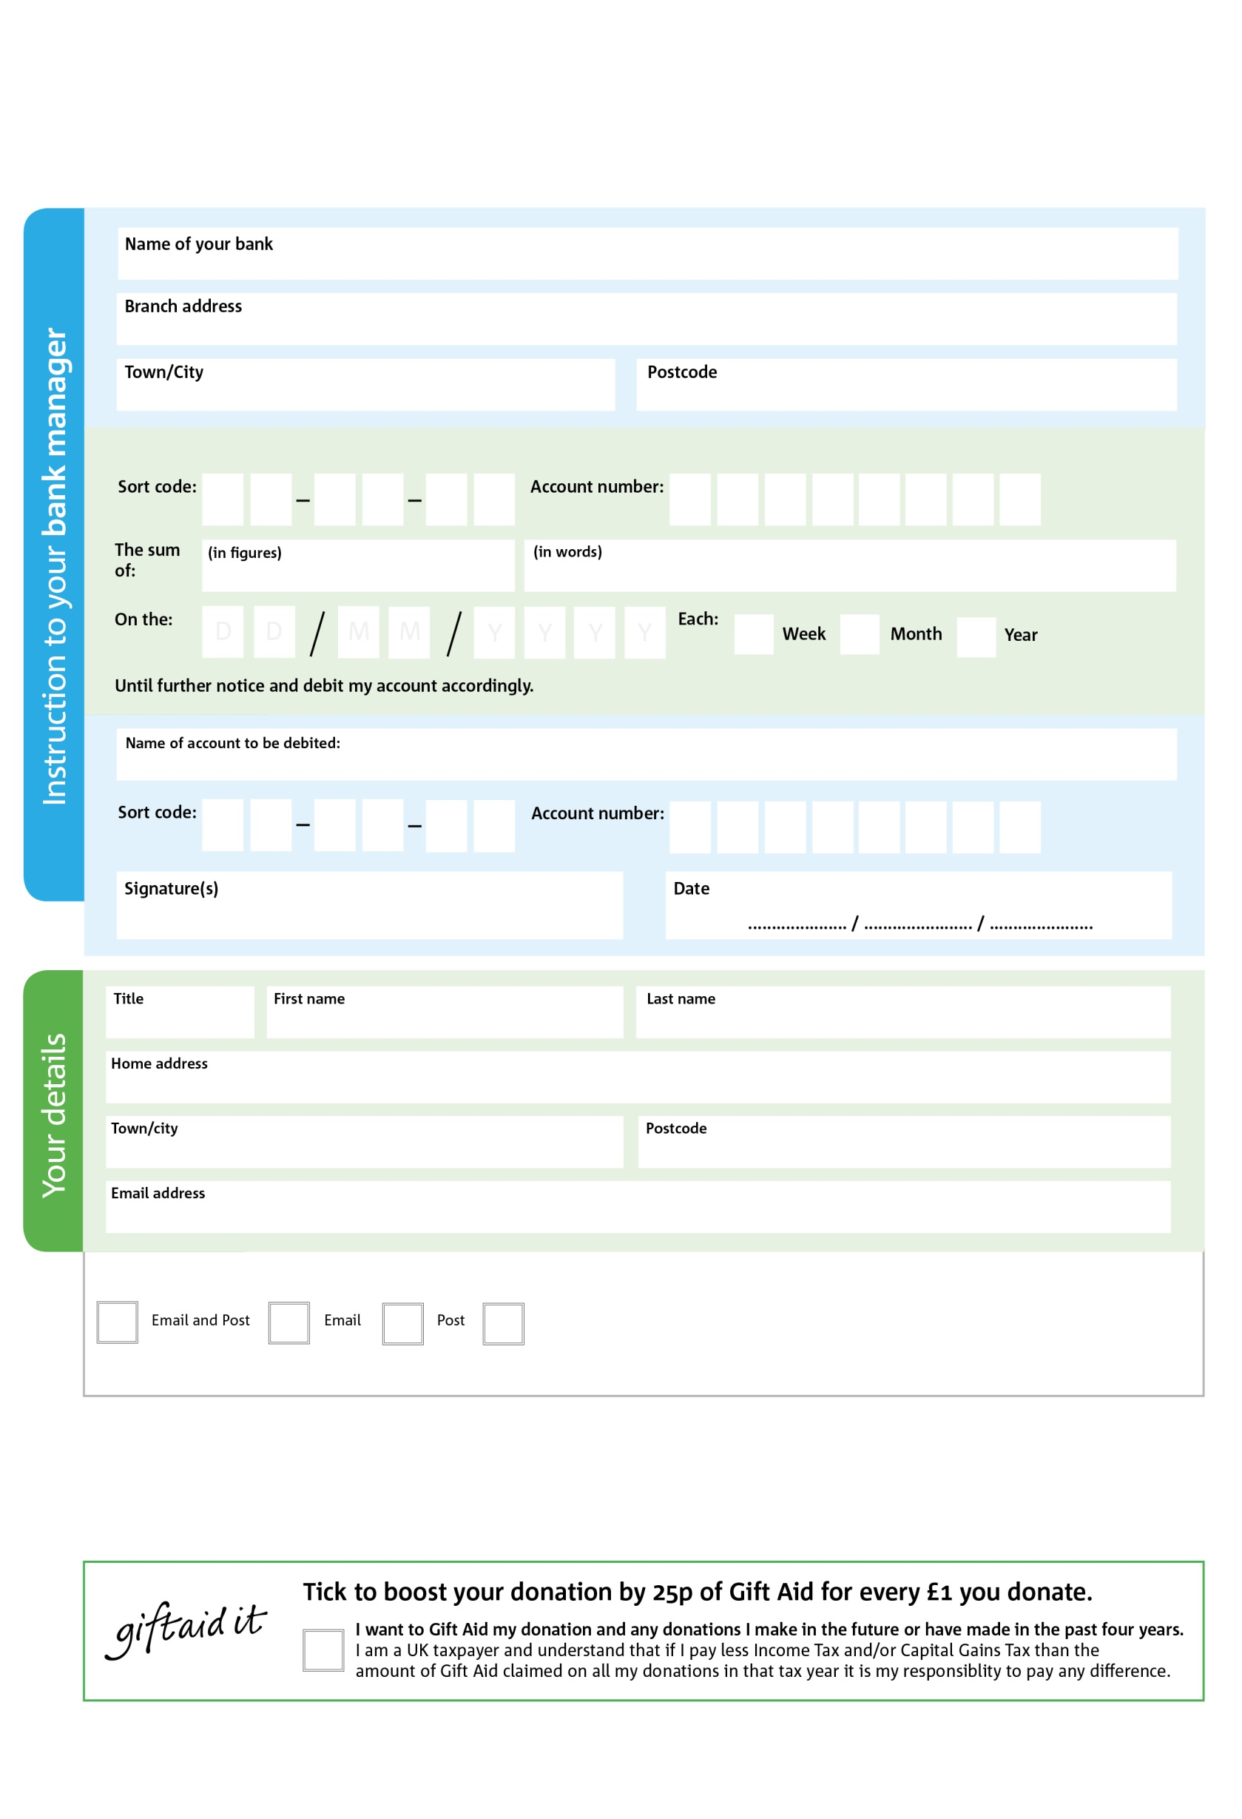



Reg. Charity No: sco42809 Reg. in Scotland

POSTAL ADDRESS: The Gate Charity, 2 Ludgate ALLOA. FK10 2DR

**Standing Order Mandate**

**www.the-gate-charity.org**

5

V

66

V

8

V

3

V

7

V

5

V

8

V

1

V

**Please pass this form into The Gate Centre, using the address at the bottom, who will save a copy for their records.   
They will then send it onto your named bank or building society.**

0

60

2

22

0

800

We would love to keep you up to date with information about The Gate Charity. Please tick your preference:

You can change your preferences any time by contacting The Gate Charity or emailing us at marie@the-gate-charity.org

I do not wish to receive future communications from The Gate Charity

Please pay The Gate Charity

**Data protection**  *The Gate Charity is committed to protecting your privacy and will process your personal data in accordance with current Data Protection legislation. The Gate collects information to keep in touch with you and supply you with information relating to our work. To unsubscribe from our newsletter, send a message to the email address above with the word unsubscribe in the subject line. A full data privacy statement for financial donors is available from The Gate on request.’*

You can change your preferences any time by contacting us on XXXXXXXXXXX or emailing us at XXXX@XXXXXXXXXX.foodbank.org.uk

I do not wish to receive future communications from XXXXXX Foodbank