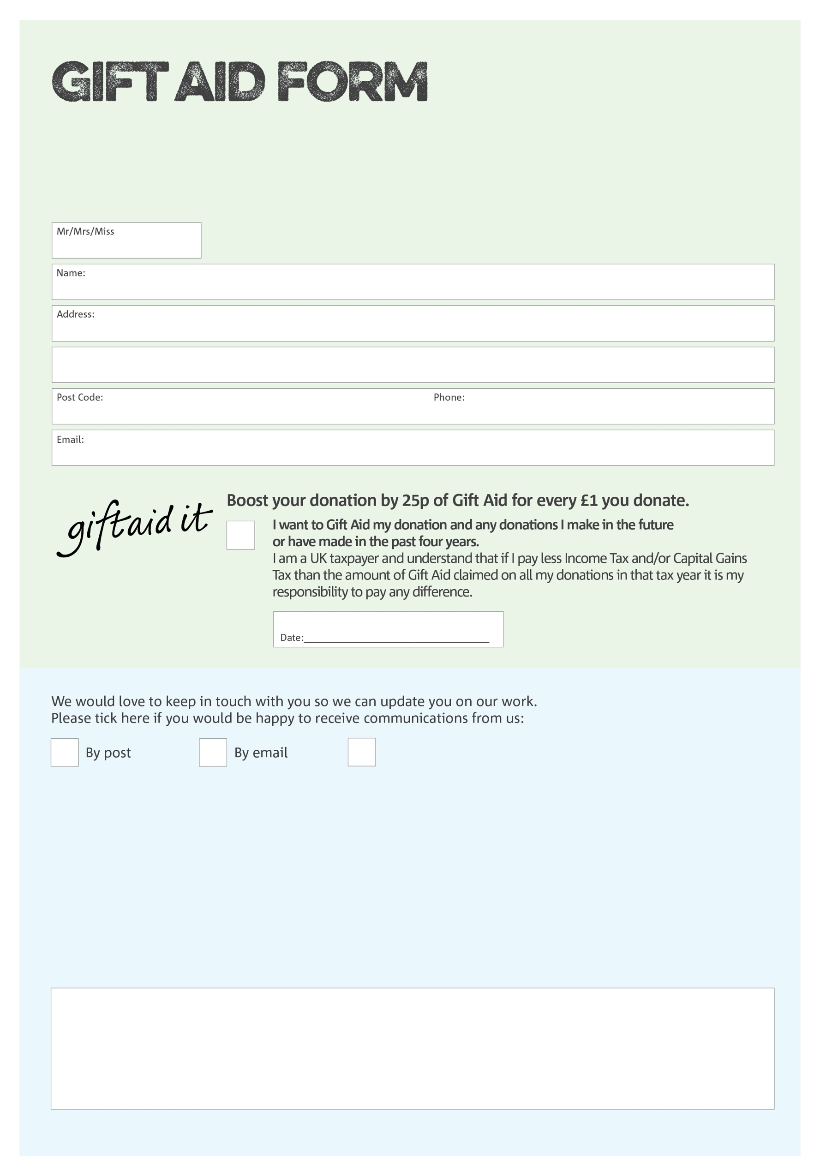



By filling in this form The Gate Charity will receive an extra 25p for every £1 you give at no extra cost to you. Please return the completed form to The Gate at the address below. Thank you for supporting our charity!

Total of Donation:

Signature: _______________________

We would love to know why you have chosen to donate to The Gate Charity. If you would like to share your motivation let us know below:

**Data protection**

*The Gate Charity is committed to protecting your privacy and will process your personal data in accordance with current Data Protection legislation. The Gate collects information to keep in touch with you and supply you with information relating to our work. To unsubscribe from our newsletter, send a message to the email address above with the word unsubscribe in the subject line. A full data privacy statement for financial donors is available from The Gate on request.’*

You can change your preferences any time by contacting us on 01259 218766 or emailing us at

marie@the-gate-charity.org

I do not wish to receive future communications from The Gate

The Gate Charity. 2 Ludgate, ALLOA. FK10 2DR. Charity Number SC042809. Registered in Scotland